# **Lab # 2: Introduction to MS Access (Queries, Reports, Forms)**

**Objective:**

1-Introduction to MS ACCESS

2-How to create tables.

3-How to create queries, reports, and forms.

**Scope:**

The student should know the following:

* MS Access basics.
* MS Access Practice.
* Basic exercises.

**Useful Concepts:**

* + Table name, its column name and column’s datatypes.
  + How to create queries on tables.
  + Forms and Reports.

**Discussion:**

Queries, Reports, Forms.

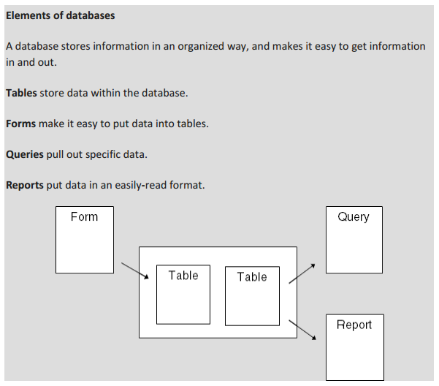

**Understanding Access Databases**

As you already know, a database is a collection of information. In Access, every database is stored in a single file. That file contains *database objects*, which are the components of a database.

Database objects are the main players in an Access database. Altogether, you have six different types of database objects:

* **Tables** store information.
* **Queries** let you quickly perform an action on a table.
* **Forms** Forms provide an easy way to view or change the information in a table.
* **Reports** help you print some or all of the information in a table.
* **Macros** are mini programs that automate custom tasks.
* **Modules** are files that contain Visual Basic code.

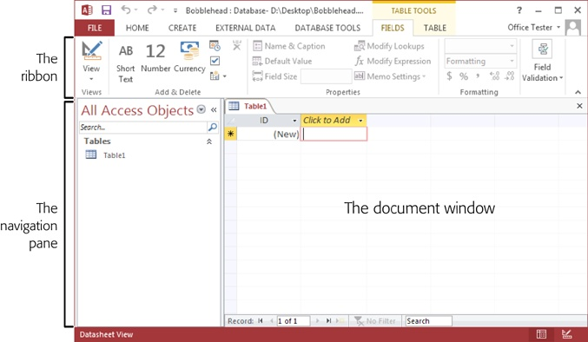

*Figure 1-1. The navigation pane on the left lets you see different items (or objects) in your database. You can use the navigation pane to jump from a list of products to a list of customers and back again. The ribbon along the top groups together every Access command. This ribbon is the mission control that lets you perform various tasks with your database. The document window in the middle takes up the rest of the window. This window is where you’ll do your work, such as designing tables and entering data.*

**Building Your First Table**

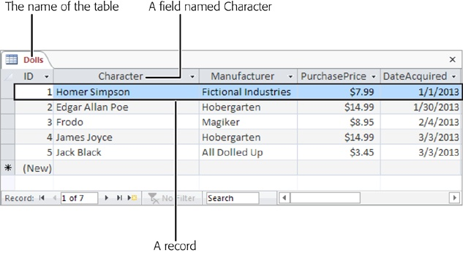

Before you start designing this table, you need to know some very basic rules:

* **A table is a group of** records.
* **Each record is subdivided into** fields.
* **Tables have a rigid structure**. If you create four fields, every record must have four fields (although it’s acceptable to leave some fields blank if they don’t apply).
* **Newly created tables get an ID field for free**. The ID field stores a unique number for each record.

**Creating a Simple Table**

When you first create a database, it’s almost empty. But to get you started, Access creates your first database object—a table named Table1.

You can customize a table in two ways:

* **Design view** lets you precisely define all aspects of a table before you start using it.
* **Datasheet view** is where you enter data into a table. Datasheet view also lets you build a table on the fly as you insert new information.

The following steps show you how to turn a blank new table (like Table1) into the Dolls table by using the Datasheet view:

1. **To define your table, simply add your first record**.
2. **In the datasheet’s rightmost column, under the “Click to Add” heading, type the first piece of information for the record (see**[**Figure 1-6**](https://www.oreilly.com/library/view/access-2013-the/9781449359447/ch01.html#to_fill_in_your_first_record_start_by_en)**).**

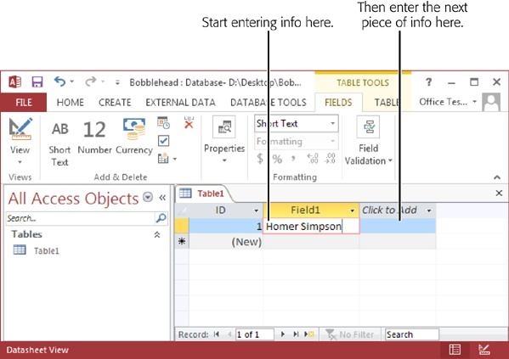

1. **Press Tab to move to the next field, and return to step 2**

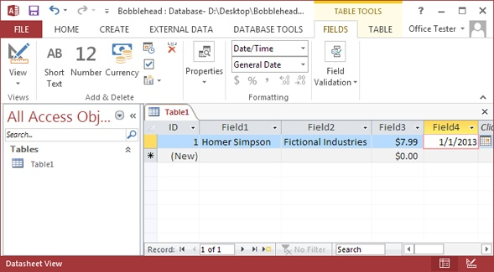

1. **It’s time to fix your column names. Double-click the first column title.**

The field name switches into Edit mode.

1. **Type a new name, and then press Enter.**

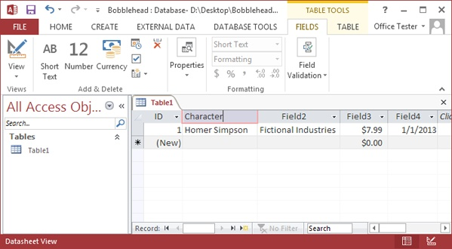

1. **Press Ctrl+S or choose File→Save to save your table**.

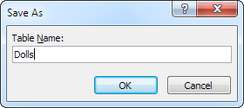

*Figure 1-9. A good table name is a short text title that doesn’t have any spaces (like Dolls here).*

1. **Type a suitable table name, and then click OK**.

Congratulations! The table is now a part of your database.

### **Editing a Table**

To fill the Dolls table, you use the same datasheet you used to define the table. You can perform three basic tasks:

* **Editing a record**.
* **Inserting a new record**.
* **Deleting a record**.

#### **Edit Mode**

Note: As you already know, you can use the arrow keys to move from field to field or row to row. However, you may have a bit of trouble editing a value. When you start typing, Access erases any existing content. To change this behavior, you need to switch into Edit mode by pressing F2; in Edit mode, your typing doesn’t delete the stuff that’s already in that field. Instead, you get to change or add to it. To switch out of Edit mode, you press F2 again.

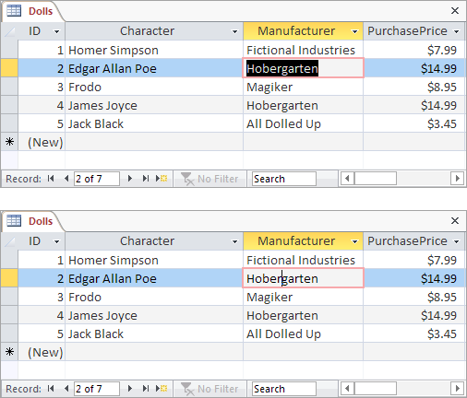

#### **Datasheet Shortcut Keys**

Power users know the fastest way to get work done is to use tricky keyboard combinations like Ctrl+Alt+Shift+*. Although you can’t always easily remember these combinations, a couple of tables can help you out. [Table 1-1](https://www.oreilly.com/library/view/access-2013-the/9781449359447/ch01.html#keys_for_moving_around_the_datasheet) lists some useful keys that can help you whiz around the datasheet.

*Table 1-1. Keys for Moving Around the Datasheet*

| **KEY** | **RESULT** |
| --- | --- |
| Tab (or Enter) | Moves the cursor one field to the right, or down when you reach the edge of the table. This key also turns off Edit mode if it’s currently switched on. |
| Shift+Tab | Moves the cursor one field to the left, or up when you reach the edge of the table. This key also turns off Edit mode. |
| → | Moves the cursor one field to the right (in Normal mode), or down when you reach the edge of the table. In Edit mode, this key moves the cursor through the text in the current field. |
| ← | Moves the cursor one field to the left (in Normal mode), or up when you reach the edge of the table. In Edit mode, this key moves the cursor through the text in the current field. |
| ↑ | Moves the cursor up one row (unless you’re already at the top of the table). This key also turns off Edit mode. |
| ↓ | Moves the cursor down one row (or it moves you to the “new row” position if you’re at the bottom of the table). This key also turns off Edit mode. |
| Home | Moves the cursor to the first field in the current row. This key brings you to beginning of the current field if you’re in Edit mode. |
| End | Moves the cursor to the last field in the current row. This key brings you to the end of the current field if you’re in Edit mode. |
| Page Down | Moves the cursor down one screenful (assuming you have a large table of information that doesn’t all fit in the Access window at once). This key also turns off Edit mode. |
| Page Up | Moves the cursor up one screenful. This key also turns off Edit mode. |
| Ctrl+Home | Moves the cursor to the first field in the first row. This key doesn’t do anything if you’re in Edit mode. |
| Ctrl+End | Moves the cursor to the last field in the last row. This key doesn’t do anything if you’re in Edit mode. |

[Table 1-2](https://www.oreilly.com/library/view/access-2013-the/9781449359447/ch01.html#keys_for_editing_records) lists some convenient keys for editing records.

*Table 1-2. Keys for Editing Records*

| **KEY** | **RESULT** |
| --- | --- |
| Esc | Cancels any changes you’ve made in the current field. This key works only if you use it in Edit mode. Once you move to the next cell, the change is applied. (For additional cancellation control, try the Undo feature, described next.) |
| Ctrl+Z | Reverses the last edit. Unfortunately, the Undo feature in Access isn’t nearly as powerful as it is in other Office programs. For example, Access lets you reverse only one change, and if you close the datasheet, you can’t even do that. You can use Undo right after you insert a new record to remove it, but you can’t use the Undo feature to reverse a delete operation. |
| Ctrl+” | Copies a value from the field that’s immediately above the current field. This trick is handy when you need to enter a batch of records with similar information. [Figure 1-11](https://www.oreilly.com/library/view/access-2013-the/9781449359447/ch01.html#an_access_user_has_been_on_an_ebay_buyin) shows this often-overlooked trick in action. |
| Ctrl+; | Inserts today’s date into the current field. The date format is based on computer settings, but expect to see something like “12-24-2013.” You’ll learn more about how Access works with dates on [Date/Time](https://www.oreilly.com/library/view/access-2013-the/9781449359447/ch02.html#datetime). |
| Ctrl+Alt+Space | Replaces whatever value you’ve entered with the field’s default value. You’ll learn how to designate a default value on [Setting Default Values](https://www.oreilly.com/library/view/access-2013-the/9781449359447/ch04.html#setting_default_values). |

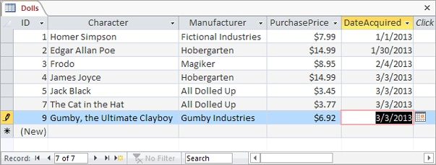

*Figure 1-11. An Access user has been on an eBay buying binge and needs to add several doll records. With a quick Ctrl+” keystroke, you can copy the date from the previous record into the DateAcquired field of the new record.*

* **Cut, Copy, and Paste**
  + 1. **Saving Databases -** automatically saves
    2. **Making Backups**

### **Saving a Database in a Different Format**

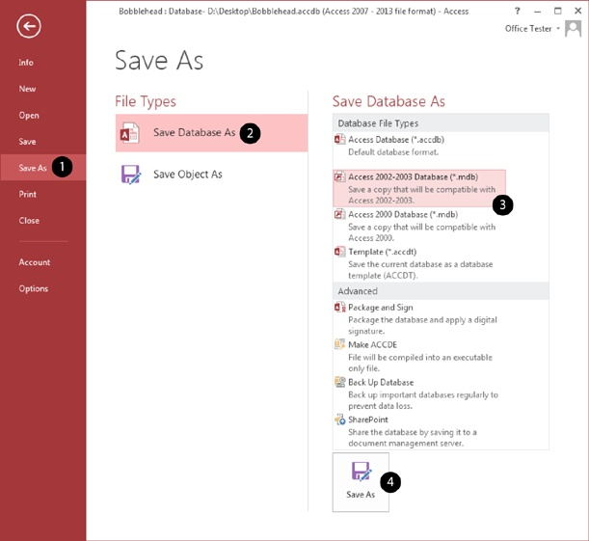

### **Shrinking a Database**

**FORMS**

There is a lot you can do design-wise with forms in Microsoft Access. You can create two basic types of forms −

* Bound forms
* Unbound forms

## **Bound Forms**

## Bound forms are connected to some underlying data source such as a table, query, or SQL statement.

## **Unbound Forms**

* These forms are not connected to an underlying record or data source.
* Unbound forms could be dialog boxes, switch boards, or navigation forms.

## **Types of Bound Forms**

There are many types of bound forms you can create in Access. Let us understand the types −

### **Single Item Form**

This is the most popular one and this is where the records are displayed — one record at a time.

### **Multiple Item Form**

This displays multiple records at a time from that bound data source.

### **Split Form**

The form is divided into halves, either vertically or horizontally. One half displays a single item or record, and the other half displays a list or provides a datasheet view of multiple records from the underlying data source.

## **Creating Forms**

There are a few methods you can use to create forms in Access. For this, open your Database and go to the **Create tab**. In the Forms group, in the upper right-hand corner you will see the Form Wizard button.

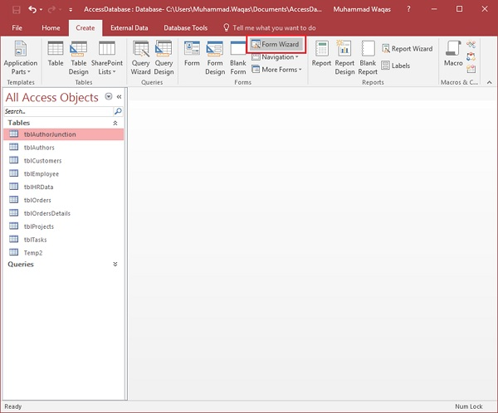

Click on that button to launch the Form Wizard.

On this first screen in the wizard, you can select fields that you want to display on your form, and you can choose from fields from more than one table or a query.

Let us assume we want to simply have a quick form that we are going to use for data entry for our employee information.

From **Tables/Queries** drop-down list, select **tblEmployees** table. Click on the double arrow to move all the fields at once.

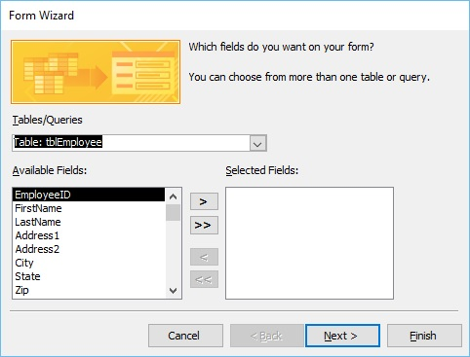

Let us just leave it with that one table, and click **Next**.

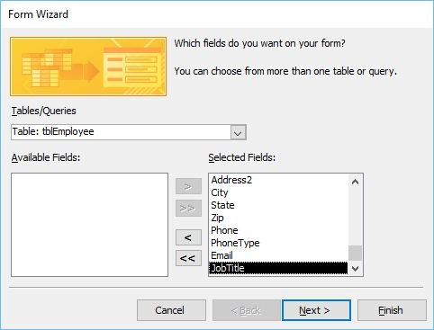

The following screen in the Form Wizard will ask for the layout that we would like for our form. We have **columnar, tabular, datasheet and justified** layouts. We will choose the columnar layout here and then click **Next**.

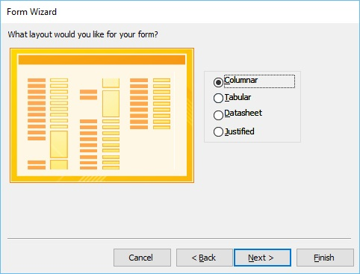

In the following screen, we need to give a title for our form. Let us call it **frmEmployees**.

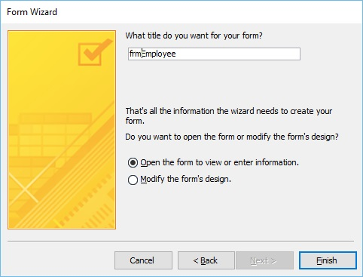

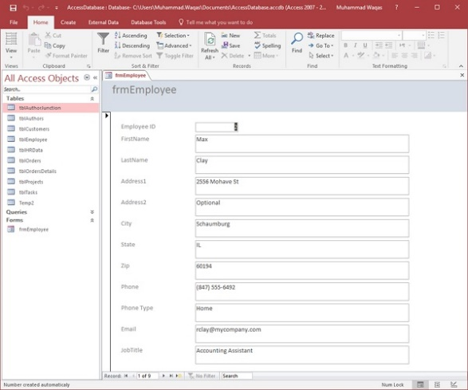

This is one example of how you can create a form using the Form Wizard. Let us now close this form and go to the Create tab. Now we will create a slightly more complicated form using Wizard. Click the Form Wizard and this time, we will choose fields from a couple of different tables.

In this Form Wizard, let us choose **tblProjects** for **Tables/Queries**, and select a few Available Fields such as ProjectID, ProjectName, ProjectStart, and ProjectEnd. These fields will now move to Selected Fields.

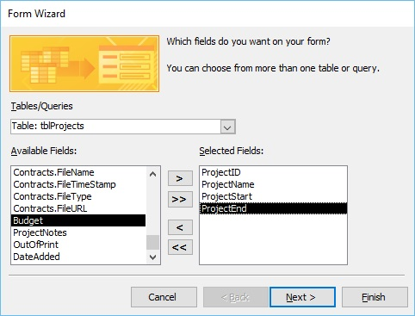

Now select **tblTasks** for Tables/Queries and send over the TaskID, ProjectID, TaskTitle, StartDate, DueDate and PercentComplete. Click **Next**.

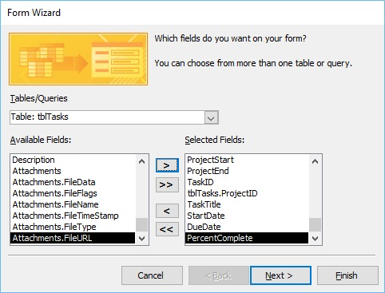

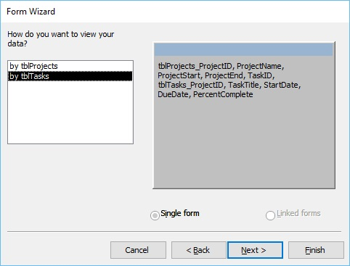

Here, we want to retrieve data from a couple of different objects. We can also choose from options on how we want to arrange our form. If we want to create a flat form, we can choose to arrange by **tblTasks**, which will create that single form, with all the fields laid out in flat view as shown above.

However, if we want to create a hierarchical form based on that one-to-many relationship, we can choose to arrange our data by tblProjects.

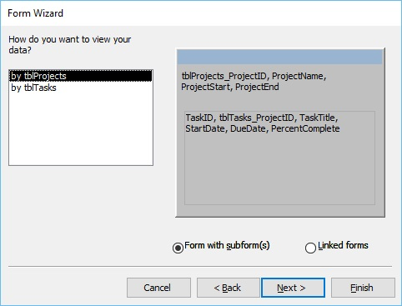

In the above window, we have the option to include a **subform** for **tblTasks**, or we can make that a linked form. This linked form is where tblProjects will have a button that will launch that second form filtered to the project that we have selected in that underlying projects form. Let us now select the **Form with subform(s)**, and then click **Next**.

In the following screen, you can choose a layout for your subform. The Datasheet View gets selected by default. The Datasheet View is similar to Table View. Now, click **Next**.

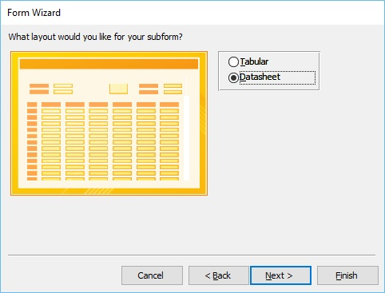

In the following screen, you need to provide a name for your forms. Enter the name you want and click **Finish**.

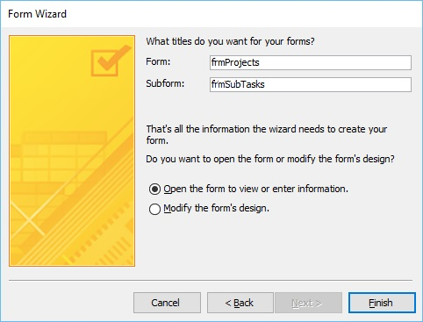

Access will give you a preview of what your form looks like. On top, you have the controls on your main form, which is from our **Projects** table. As you go down, you will see a subform. It's like a form within a form.

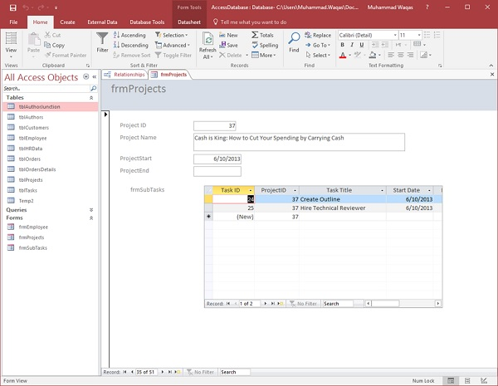

## **Multiple Item Form**

You may also want to create a specific kind of form. For this, you can click on the **More Forms** drop-down menu.

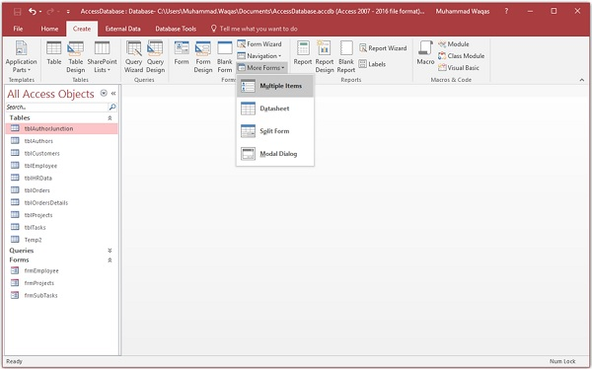

From the menu, you can create a **Multiple Items** form, a **Datasheet** form, a **Split** form, or even a **Modal Dialog** form. These are typically bound forms; select the object that you would like to be bound to that form. This does not apply to the Modal Dialog forms.

To create this type of form, you will need to select the object in navigation pane first. Let us select **tblEmployees** here.

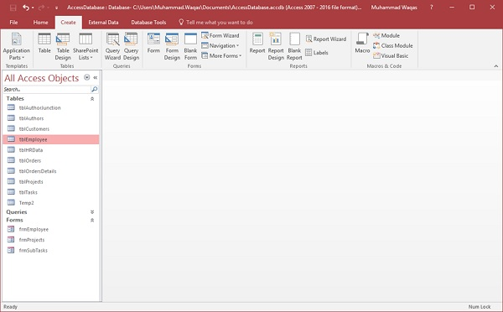

Proceed by clicking on **More Forms** and **Multiple Items**.

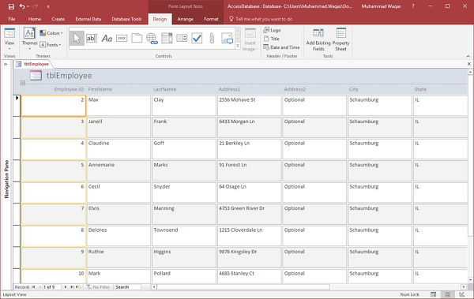

The above step will further create a Multiple Items form, listing out all the employees.

## **Split Form**

This type of form is divided in equal halves, either vertically or horizontally. One half displays a single item or record, and the other half displays a list or a datasheet view of multiple records from the underlying data source.

Let us now select **tblEmployees** in the navigation pane and then on **Create** tab. Select **Split Form** option from More Forms menu and you will see the following form in which the form is divided vertically.

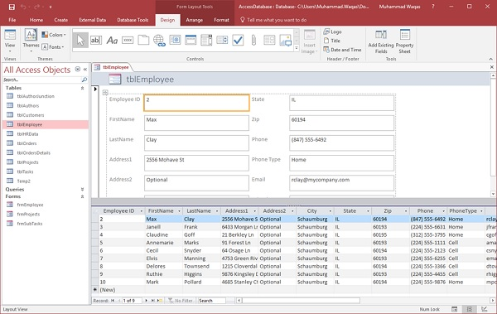

**REPORTS**

Reports offer a way to view, format, and summarize the information in your Microsoft Access database. For example, you can create a simple report of phone numbers for all your contacts.

### **Example**

We will now take a simple example to understand the process of creating a very simple report. For this, we need to go to the Create tab.

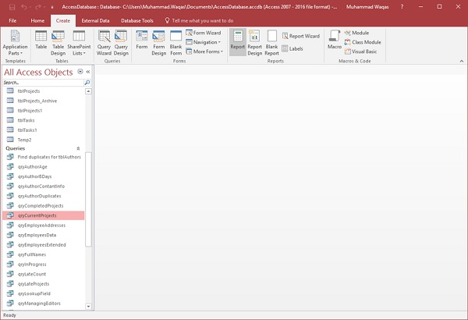

Before clicking on the Report button to create a basic report, make sure the proper query is selected. In this case, **qryCurrentProjects** is selected in your navigation pane. Now click on the Report button, which will generate a report based on that query.

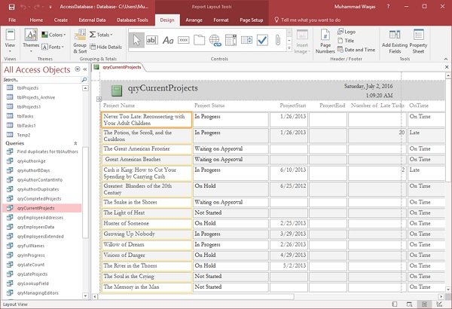

You will see that the report is open in Layout view. This provides a quick way to adjust the size or width of any of your fields that you see on the report. Let us now adjust the column widths to make everything fit in a better way.

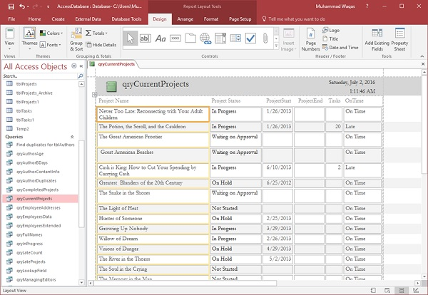

Scroll down and adjust the page control at the bottom.

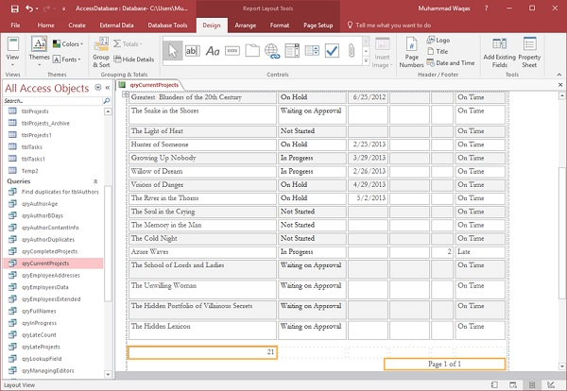

This was a very quick way to create a very simple report. You could also make minor changes and adjustments from the report design view.

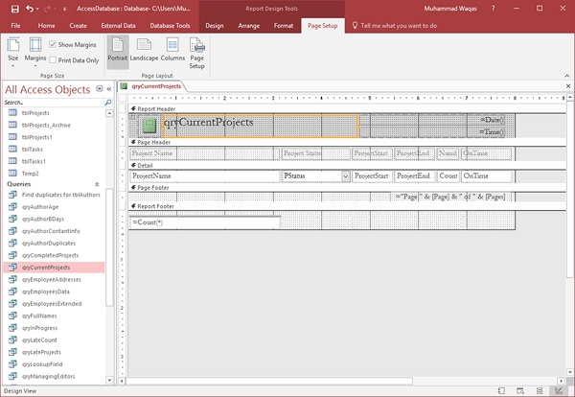

* Just like forms, a report is made up of a variety of different sections.
* You have the detail section, which is where all your data lives for the most part.
* You also will see a page header and a page footer section; these appear at the top and at the bottom of every single page in your report.

Let us now change the Title of the report and give it another name.

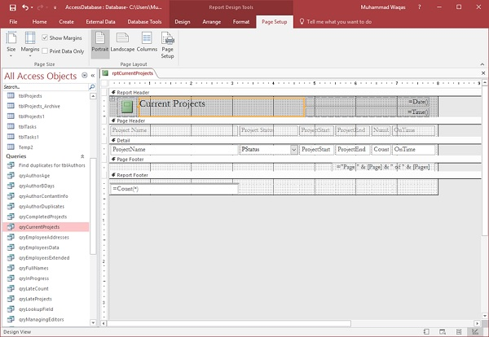

Click on the save icon to save your report.

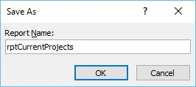

You will get the above dialog box.

Enter a name for your report and click Ok. If you want to view what this report will actually look like, in Print Preview, you can go back to the View button and click on Print Preview to see what this report would look like when printed either on paper or as a PDF.

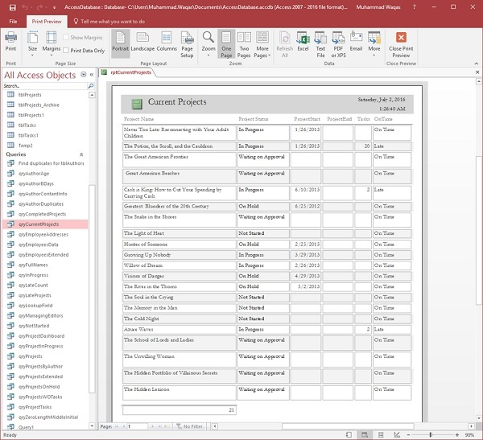

## **Create a Report Using Report Design**

Report Design is another method for creating a quick report in Access. For this, we need to use the Report Design View button, which is like the Form Design button. This will create a blank report and open it directly to the Design View, allowing you to change the control source and add fields directly to the Design View of the report.

Let us now go to the Create tab and click on the Report Design button.

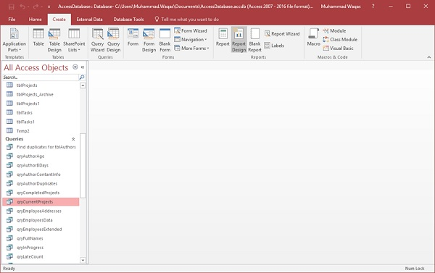

It will open a blank report or an unbound report, meaning this report is connected to no other object in our database.

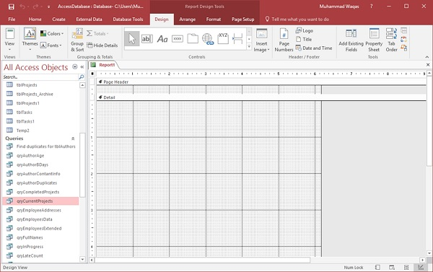

On the Design tab in the Tools group, select the Property Sheet. This will open up the Property pane.

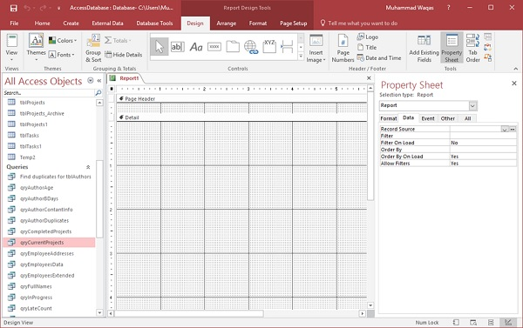

On the Data tab, assign a record source to this report, to connect it to a database object as in the following screenshot.

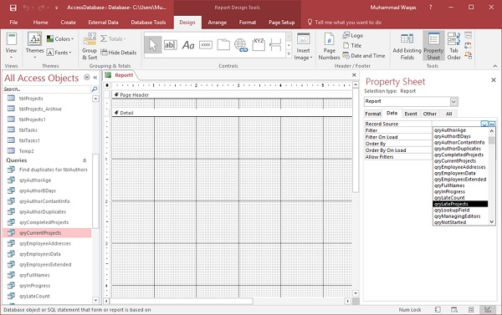

Select **qryLateProjects** from the drop-down and now, the next step is to go through and add some fields to this report by clicking on Add Existing Fields list button on the Design tab.

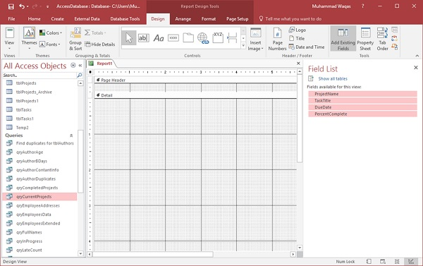

Select the fields as in the above screenshot.

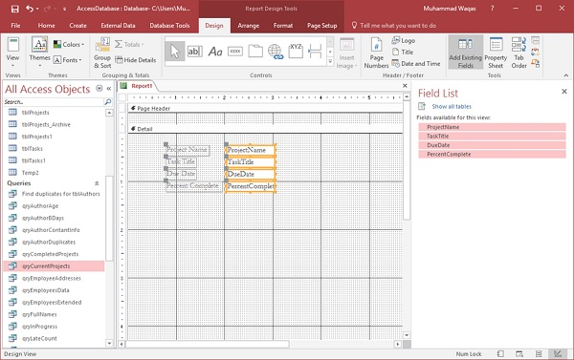

Drag the fields to you report as in the above screenshot. Go the Arrange tab, and in the Table group, you have a couple of options to choose from.

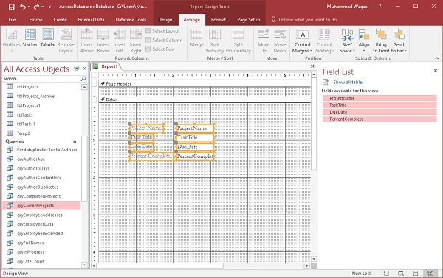

There is a stacked layout and a tabular layout, which is a layout that is very similar to a spreadsheet. Let us select the tabular layout.

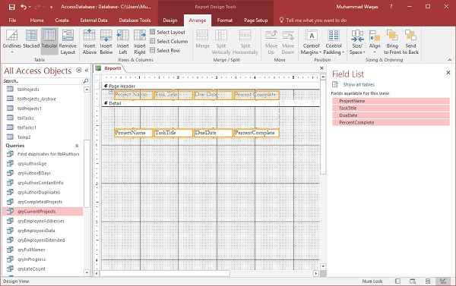

You can see that it moves all of the labels up to the page header area. These labels will appear only once at the top of every page and the data query will repeat for every record in the Details section. Now, you can go through and make some adjustments to make your ProjectName field wider.

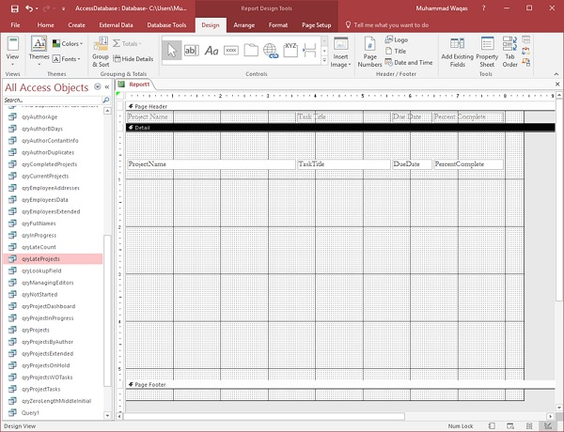

As you can see in the above screenshot, there is a lot of space between Detail section and Page Footer.

Let us drag the Page Footer up to reduce the space as in the following screenshot. We will now go to the Design tab and click on the View button and choose Report View.

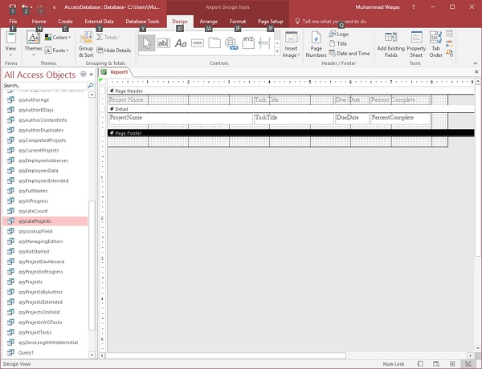

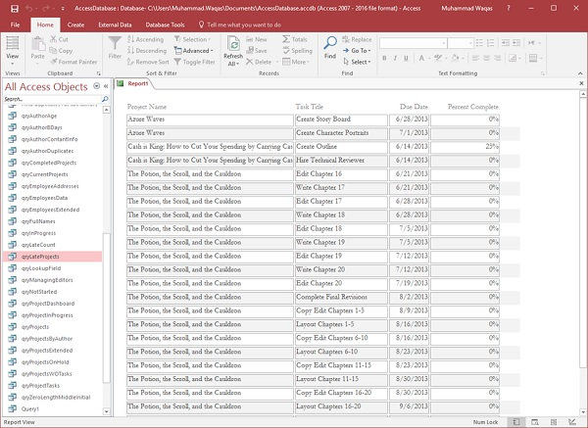

You can now see that some project names are not complete; you can adjust this with either the design view, or you can use the layout view to do that.

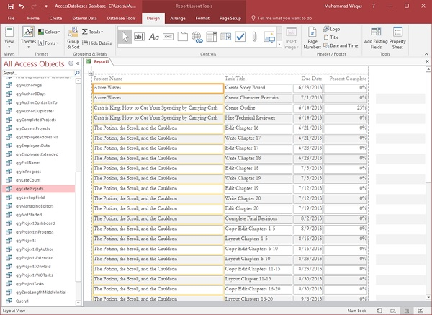

That is how we create a simple report just from the Design View.

**Queries**

A query is a request for data results, and for action on data. You can use a query to answer a simple question, to perform calculations, to combine data from different tables, or even to add, change, or delete table data.

## **Create Select Query**

If you want to review data from only certain fields in a table, or review data from multiple tables simultaneously or maybe just see the databased on certain criteria, you can use the **Select** query. Let us now look into a simple example in which we will create a simple query which will retrieve information from **tblEmployees** table. Open the database and click on the **Create** tab.

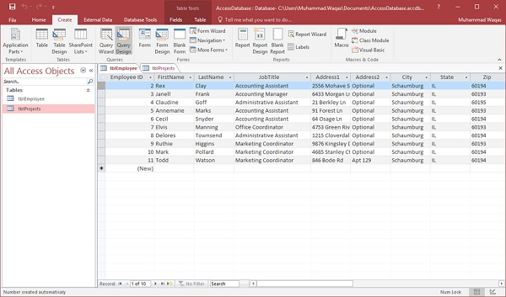

Click **Query Design**.

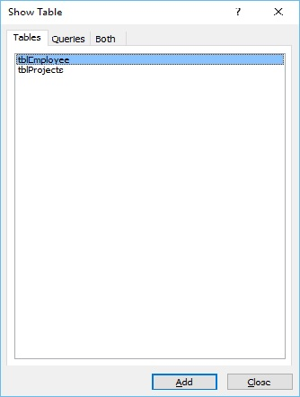

In the **Tables** tab, on the **Show Table** dialog, double-click the **tblEmployees** table and then **Close** the dialog box.

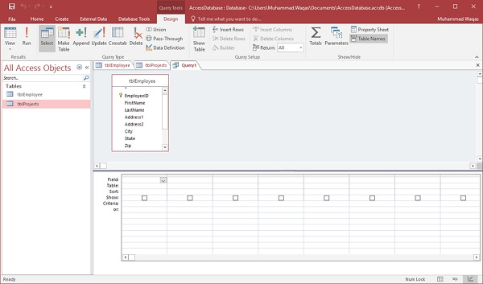

In the tblEmployees table, double-click all those fields which you want to see as result of the query. Add these fields to the query design grid as shown in the following screenshot.

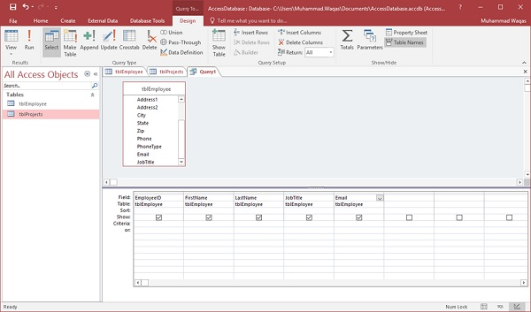

Now click **Run** on the **Design** tab, then click **Run**.

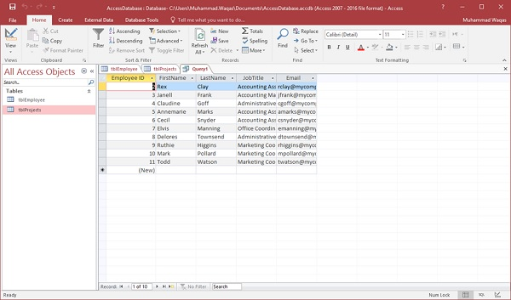

The query runs, and displays only data in those field which is specified in the query.

Tasks

* 1. Create a table **Student** with the following fields.

F_Name, L_Name, RollNumber, City, CNIC, department, Gender, Semester, CGPA.

* 1. Create a table **Library** with the following fields.

ISBN, Book_title, No_Copies, studentID, issuedDate.

* 1. Insert 10 records (at least) in both tables using *Datasheet view.*
  2. Create a form for both the tables and then insert 5 more records using forms in the tables.
  3. Create one-to-many relationship between student and library.
  4. After *task 5*, create sub-form and split form for both tables.
  5. Implement the following queries.

1. Show all fields of those students who lived in *Rawalpindi*.
2. Display the book title issued by those students whose CGPA > 3.
   1. Make a report for both queries.